🚀 Azure Data Engineer Interview Series | Day 1/21
Preparing for Azure Data Engineer interviews?
Over the next 21 days, I'll share important interview questions with simple explanations, real-world examples, and practical tips.
Let's start with one of the most common questions.
❓ What is Azure Data Factory (ADF)?
Azure Data Factory (ADF) is Microsoft's cloud-based data integration and orchestration service.
Think of it as the conductor of an orchestra—it connects different systems, moves data, schedules workflows, and automates end-to-end data pipelines.
💼 Real-World Example
A typical nightly pipeline might:
✅ Extract data from SQL Server
✅ Store it in Azure Data Lake (ADLS)
✅ Trigger an Azure Databricks notebook for transformation
✅ Load the data into Azure Synapse
✅ Refresh Power BI dashboards
Instead of running these steps manually, Azure Data Factory automates the entire workflow.
🔹 ADF → Data Movement & Orchestration
🔹 Azure Databricks → Data Transformation & Business Logic
Knowing this difference can make your interview answers much stronger.
hashtag#Azure hashtag#AzureDataFactory hashtag#AzureDataEngineer hashtag#AzureDatabricks hashtag#DataEngineering hashtag#PySpark hashtag#SQL
Activate to view larger image,
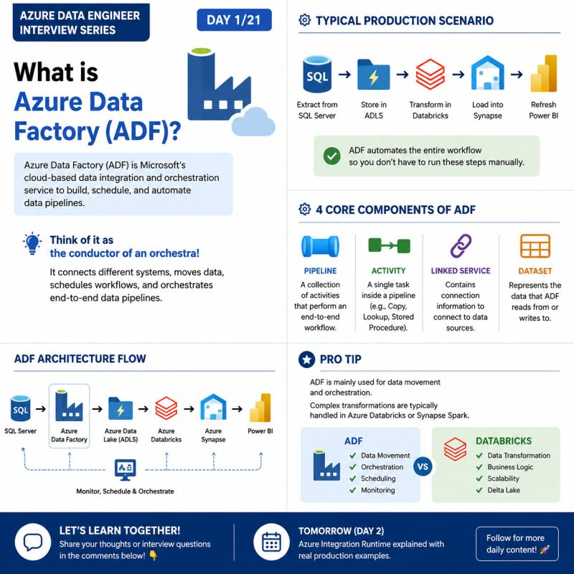

🚀 Azure Data Engineer Interview Series | Day 2/21
One question that almost every Azure Data Engineer interviewer asks:
❓ What is Integration Runtime (IR) in Azure Data Factory?
Integration Runtime (IR) is the compute infrastructure used by Azure Data Factory to move data, execute activities, and connect to different data sources.
In simple words, IR acts as a bridge between Azure Data Factory and your data sources.
💼 Real-World Scenario
Imagine your company's SQL Server is hosted on-premises behind a firewall.
Since Azure Data Factory is a cloud service, it cannot connect directly to your on-prem SQL Server.
This is where Self-Hosted Integration Runtime (SHIR) comes in.
It securely connects Azure Data Factory with your on-premises resources and enables data movement without exposing your network.
🎯 Types of Integration Runtime
🔹 Azure Integration Runtime – Used for cloud-to-cloud data movement.
🔹 Self-Hosted Integration Runtime – Used for connecting to on-premises or private network resources.
🔹 Azure SSIS Integration Runtime – Used for running existing SSIS packages in Azure.
💡 Pro Tip
A common interview question is:
When should you use Self-Hosted Integration Runtime?
✅ When your data source is on-premises
✅ When the source is behind a firewall
✅ When you need secure connectivity to private network resources
💬 Let's learn together!
Have you ever configured Self-Hosted Integration Runtime in a real project?
Or has this question been asked in your interview?
👇 Share your experience in the comments.
📅 Tomorrow (Day 3): Watermark Incremental Load in Azure Data Factory with a real production example.
hashtag#Azure hashtag#AzureDataFactory hashtag#AzureDataEngineer hashtag#IntegrationRuntime hashtag#AzureDatabricks hashtag#DataEngineering hashtag#MicrosoftAzure hashtag#ADF
Activate to view larger image,
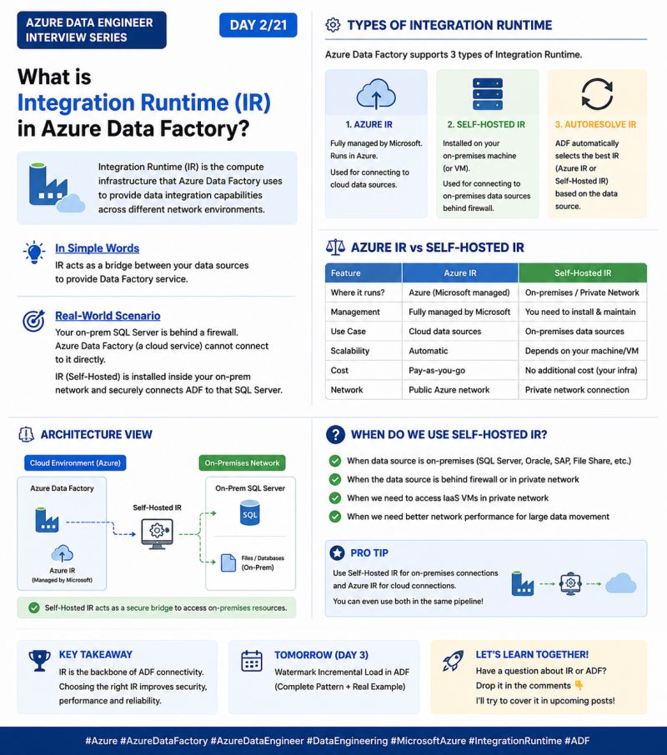
See content credentials
Activate to view larger image,

🚀 Azure Data Engineer Interview Series | Day 3/21
One question that interviewers frequently ask:
❓ What is Watermark Incremental Load in Azure Data Factory?
Loading millions of records every day is inefficient.
Instead, most enterprise projects use Watermark Incremental Load, which loads only the new or updated records since the last successful pipeline run.
💼 Real-World Scenario
Imagine an e-commerce company with millions of orders stored in SQL Server.
Running a full load every night would waste time and compute resources.
With Watermark Incremental Load, ADF checks the latest processed value (such as LastModifiedDate) and loads only the records that were added or updated after that point.
🎯 How It Works
✅ Read the latest watermark value from the destination or a control table.
✅ Query the source using a filter like:
LastModifiedDate > WatermarkValue
✅ Load only the incremental records.
✅ Update the watermark after a successful pipeline run.
💡 Pro Tip
Choose a reliable watermark column such as:
LastModifiedDate
UpdatedDate
Timestamp
This approach reduces processing time, lowers costs, and improves pipeline performance for large datasets.
💬 Let's learn together!
Have you implemented Incremental Load in Azure Data Factory or Databricks?
Or which strategy do you use—Watermark or CDC (Change Data Capture)?
👇 Share your experience in the comments!
📅 Tomorrow (Day 4): Azure Data Factory Triggers explained with real-world examples.
hashtag#Azure hashtag#AzureDataFactory hashtag#AzureDataEngineer hashtag#ADF hashtag#DataEngineering hashtag#AzureDatabricks hashtag#SQL hashtag#InterviewPreparation hashtag#interview hashtag#jobs
Activate to view larger image,
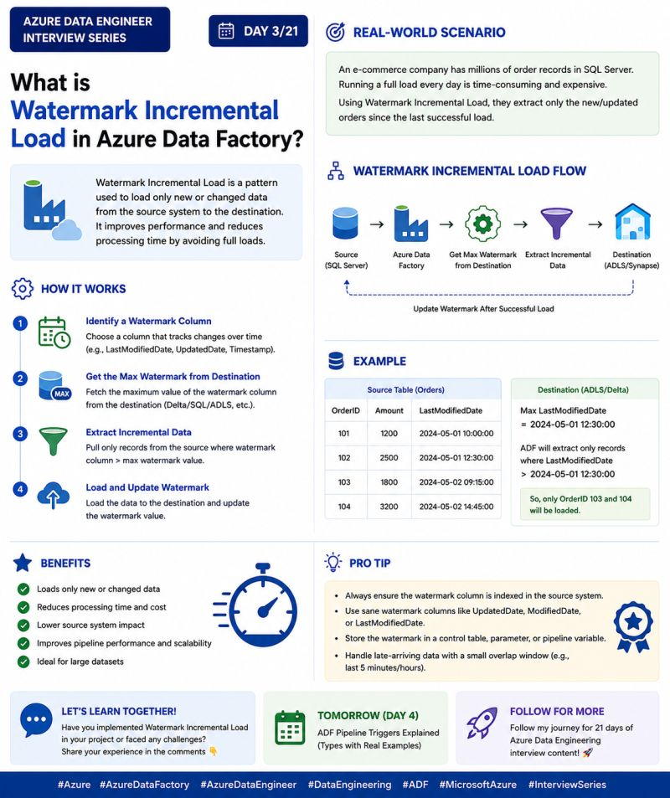

🚀 Azure Data Engineer Interview Series | Day 4/21
One interview question that every Azure Data Engineer should know:
❓ What are Triggers in Azure Data Factory?
A Trigger is used to automatically start a pipeline in Azure Data Factory based on a schedule, an event, or a specific condition.
Instead of running pipelines manually, triggers help automate your data workflows.
💼 Real-World Scenario
Imagine your company receives sales files in an Azure Data Lake Storage (ADLS) folder every day.
Rather than waiting for someone to start the pipeline manually, you can configure an Event Trigger.
As soon as a new file arrives:
✅ Pipeline starts automatically
✅ Data is processed
✅ Data is loaded into Azure Synapse
✅ Power BI dashboards are refreshed
No manual intervention required.
🎯 Types of Triggers in ADF
🔹 Schedule Trigger – Runs a pipeline at a specific time (e.g., every day at 1:00 AM).
🔹 Event Trigger – Starts a pipeline when an event occurs, such as a new file arriving in ADLS.
🔹 Tumbling Window Trigger – Executes pipelines for fixed time windows, commonly used for time-series and batch processing.
💡 Pro Tip
Interviewers often ask:
When should you use an Event Trigger instead of a Schedule Trigger?
✔️ Schedule Trigger → When the pipeline must run at fixed intervals.
✔️ Event Trigger → When the pipeline should start immediately after an event, such as a file upload.
Knowing the right trigger for the right scenario is a common interview discussion.
💬 Let's learn together!
Which trigger do you use most in your projects—Schedule Trigger or Event Trigger?
👇 Share your experience in the comments!
📅 Tomorrow (Day 5): Lookup Activity in Azure Data Factory with a real production example.
hashtag#Azure hashtag#AzureDataFactory hashtag#AzureDataEngineer hashtag#ADF hashtag#DataEngineering hashtag#AzureSynapse hashtag#AzureDatabricks hashtag#InterviewPreparation hashtag#job hashtag#interview
Activate to view larger image,
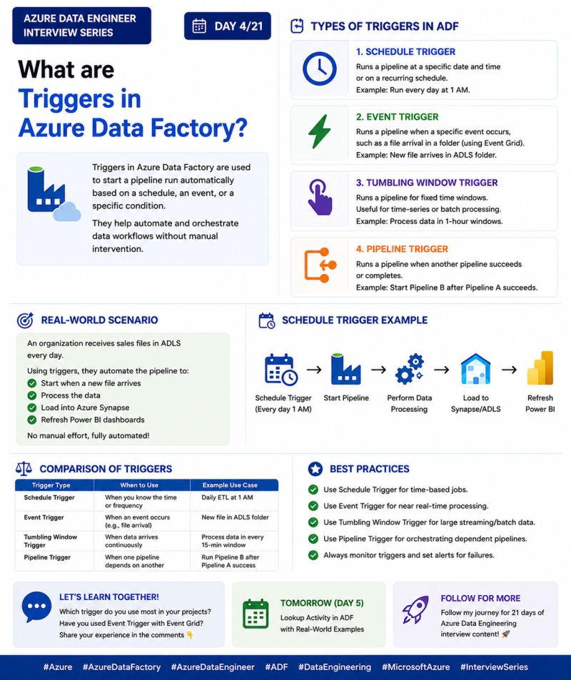

🚀 Azure Data Engineer Interview Series | Day 5/21
One Azure Data Factory activity that almost every real-world project uses:
❓ What is Lookup Activity in Azure Data Factory?
Lookup Activity is used to retrieve data from a source during pipeline execution.
It can return a single row or multiple rows, and its output can be used to control the flow of the pipeline.
Think of it as asking your database a question before deciding what your pipeline should do next.
💼 Real-World Scenario
Imagine you have a metadata table containing:
Table Name
Source File
Load Type (Full / Incremental)
Instead of creating separate pipelines for each table, you can:
✅ Use Lookup Activity to read the metadata.
✅ Pass the output to a ForEach Activity.
✅ Process every table dynamically.
This makes your pipeline reusable, scalable, and easy to maintain.
🎯 Common Use Cases
🔹 Read configuration values from a SQL table
🔹 Get the latest Watermark value for Incremental Load
🔹 Fetch a list of files or tables
🔹 Drive a metadata-driven pipeline
💡 Pro Tip
Interviewers often ask:
"Why use Lookup instead of hardcoding values?"
Because Lookup makes your pipeline dynamic.
Instead of modifying the pipeline every time a new table or file is added, simply update the metadata table—your pipeline automatically picks up the changes.
That's how enterprise ETL pipelines are usually designed.
💬 Let's learn together!
Have you used Lookup Activity with ForEach in your projects?
Or have you built a metadata-driven pipeline using ADF?
👇 Share your experience in the comments!
📅 Tomorrow (Day 6): ForEach Activity in Azure Data Factory with a real-world example.
hashtag#Azure hashtag#AzureDataFactory hashtag#AzureDataEngineer hashtag#ADF hashtag#DataEngineering hashtag#AzureDatabricks hashtag#ETL hashtag#InterviewPreparation hashtag#interview hashtag#job hashtag#dataengineer
Activate to view larger image,
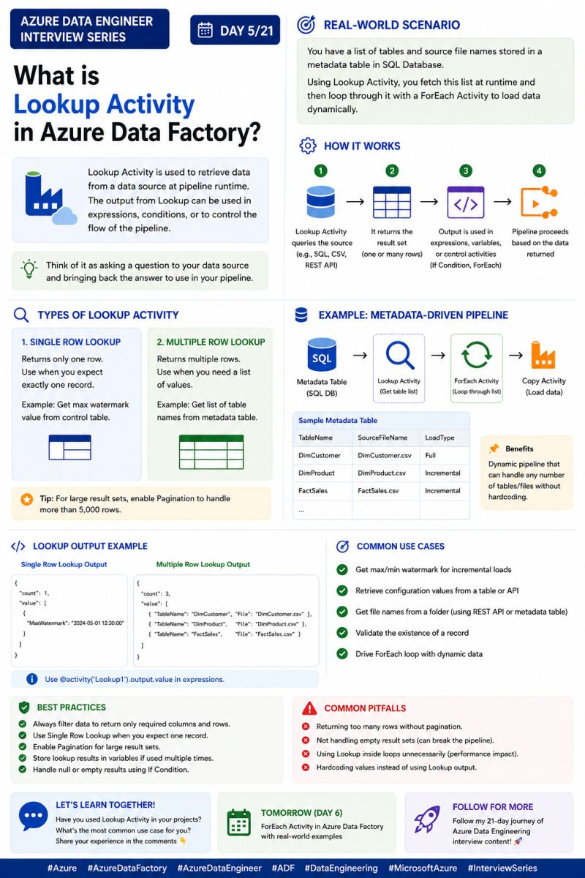

🚀 Azure Data Engineer Interview Series | Day 6/21
One topic that separates beginners from experienced Azure Data Engineers:
❓ How do you handle errors in Azure Data Factory (ADF)?
In real-world projects, pipeline failures are inevitable.
A robust data pipeline doesn't just process data—it also detects failures, retries temporary issues, logs errors, and alerts the support team.
That's where Error Handling in Azure Data Factory becomes essential.
💼 Real-World Scenario
Imagine your nightly ETL pipeline copies data from SQL Server to Azure Data Lake.
Suddenly, the SQL Server becomes temporarily unavailable.
Instead of failing immediately, you can:
✅ Retry the activity automatically
✅ Log the error details
✅ Send an email or Teams notification
✅ Continue or stop the pipeline based on your business requirements
This makes your pipeline more reliable and production-ready.
🎯 Common Error Handling Techniques
🔹 Retry Policy – Automatically retries failed activities for temporary issues.
🔹 Dependency Conditions – Execute different activities based on Success, Failure, or Completion.
🔹 Try-Catch Pattern – Handle failures gracefully instead of stopping the entire pipeline.
🔹 Fail Activity – End the pipeline with a custom error message when required.
💡 Pro Tip
One common interview question is:
"How do you handle failures in production pipelines?"
A strong answer is:
✔️ Configure Retry Policy for transient failures
✔️ Log errors for debugging
✔️ Send notifications to the support team
✔️ Use Dependency Conditions to control the next steps
This shows that you understand production-ready pipeline design, not just ADF activities.
💬 Let's learn together!
How do you handle pipeline failures in your projects?
Do you use Retry Policy, Try-Catch, or a custom logging framework?
👇 Share your approach in the comments.
📅 Tomorrow (Day 7): Azure Data Factory Interview Cheat Sheet – A one-page revision guide for interviews.
hashtag#Azure hashtag#AzureDataFactory hashtag#AzureDataEngineer hashtag#ADF hashtag#DataEngineering hashtag#AzureDatabricks hashtag#ETL hashtag#InterviewPreparation hashtag#MicrosoftAzure hashtag#job hashtag#jobs hashtag#interview hashtag#dataengineer
Activate to view larger image,
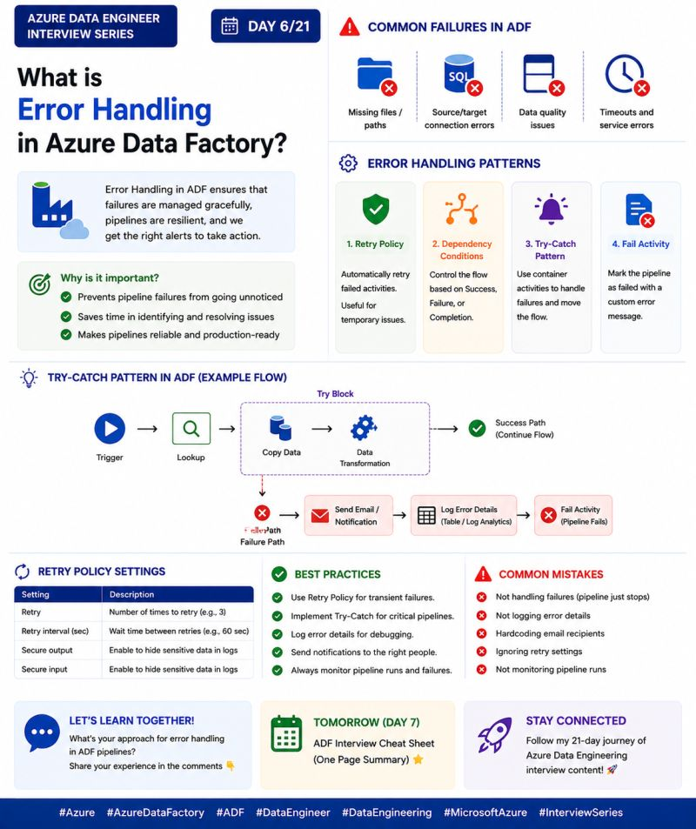

🚀 Azure Data Engineer Interview Series | Day 7/21
📌 Azure Data Factory Interview Cheat Sheet
Preparing for an Azure Data Engineer interview?
Here's a quick revision guide covering the most important Azure Data Factory concepts in one place.
✅ Azure Data Factory Essentials
🔹 Pipeline → A workflow that contains one or more activities.
🔹 Activity → A single task such as Copy, Lookup, Stored Procedure, or Notebook execution.
🔹 Linked Service → Stores the connection details to data sources.
🔹 Dataset → Represents the data that ADF reads or writes.
✅ Integration Runtime (IR)
✔️ Azure IR → Cloud-to-cloud data movement.
✔️ Self-Hosted IR → Connects to on-premises and private network resources.
✔️ Azure SSIS IR → Runs existing SSIS packages in Azure.
✅ Incremental Load
Instead of loading the entire dataset every time,
➡️ Read the latest Watermark value
➡️ Load only new or updated records
➡️ Update the Watermark after a successful load
✅ Dynamic Pipelines
Lookup Activity → Fetch metadata
⬇️
ForEach Activity → Iterate through the list
⬇️
Copy Activity → Process tables/files dynamically
✅ Error Handling
✔️ Retry Policy
✔️ Dependency Conditions
✔️ Try-Catch Pattern
✔️ Fail Activity
✔️ Logging & Notifications
💡 Interview Tip
If you're asked:
"Explain your ADF project."
Don't list activities one by one.
Instead, explain the complete flow:
Source → ADF → ADLS → Databricks → Synapse → Power BI
Interviewers are more interested in how you design an end-to-end solution than whether you can define individual activities.
🎯 7-Day ADF Journey Completed!
✔️ Day 1 – Azure Data Factory
✔️ Day 2 – Integration Runtime
✔️ Day 3 – Watermark Incremental Load
✔️ Day 4 – Lookup + ForEach Dynamic Pipeline
✔️ Day 5 – Metadata-Driven Pipeline
✔️ Day 6 – Error Handling
✔️ Day 7 – ADF Interview Cheat Sheet
💬 Let's learn together!
Which Azure Data Factory topic do you find most challenging during interviews?
👇 Share it in the comments!
📅 Tomorrow (Day 8): What is Azure Databricks?
hashtag#Azure hashtag#AzureDataFactory hashtag#AzureDataEngineer hashtag#ADF hashtag#DataEngineering hashtag#AzureDatabricks hashtag#InterviewPreparation hashtag#MicrosoftAzure hashtag#ETL
Activate to view larger image,
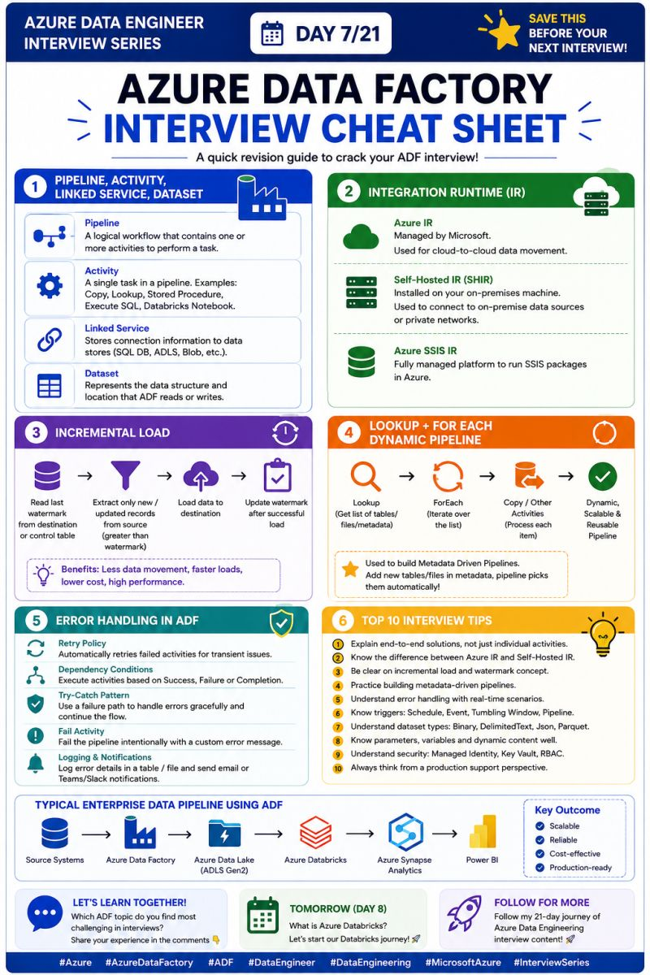

🚀 Azure Data Engineer Interview Series | Day 8/21
Today, we're starting one of the most important topics for every Azure Data Engineer...
❓ What is Azure Databricks?
Azure Databricks is a cloud-based unified analytics platform built on Apache Spark.
It enables Data Engineers, Data Scientists, and Analysts to process, transform, analyze, and visualize massive amounts of data—all in one collaborative workspace.
Think of it as the processing engine of a modern data platform.
💼 Real-World Scenario
Imagine your company receives 500 GB of sales data every day from multiple systems.
Instead of writing complex ETL jobs on individual servers, Azure Databricks allows you to:
✅ Process large-scale data using Apache Spark
✅ Clean and transform data efficiently
✅ Store it in Delta Lake
✅ Load curated data into Azure Synapse
✅ Build Power BI dashboards for business users
This is why Azure Databricks is widely used in modern data engineering projects.
🎯 Key Components
🔹 Workspace – Collaborative environment for development.
🔹 Clusters – Compute resources that execute Spark jobs.
🔹 Notebooks – Interactive coding environment supporting Python, SQL, Scala, and R.
🔹 Jobs – Schedule and automate notebook execution.
🔹 Delta Lake – Reliable storage layer with ACID transactions.
💡 Interview Tip
One common interview question is:
"Why Azure Databricks instead of traditional ETL tools?"
A strong answer:
✔️ Distributed processing using Apache Spark
✔️ Handles massive datasets efficiently
✔️ Seamless integration with Azure services
✔️ Supports Data Engineering, Machine Learning, and Analytics in one platform
Interviewers appreciate candidates who explain where Databricks fits into the overall data architecture, not just what it is.
💬 Let's learn together!
Have you worked with Azure Databricks in your projects?
What's your favourite feature—Notebooks, Delta Lake, or Spark Clusters?
👇 Share your experience in the comments!
📅 Tomorrow (Day 9): Delta Lake vs Parquet – What's the difference?
hashtag#Azure hashtag#AzureDatabricks hashtag#AzureDataEngineer hashtag#ApacheSpark hashtag#PySpark hashtag#DeltaLake hashtag#DataEngineering hashtag#BigData hashtag#MicrosoftAzure hashtag#InterviewPreparation
Activate to view larger image,
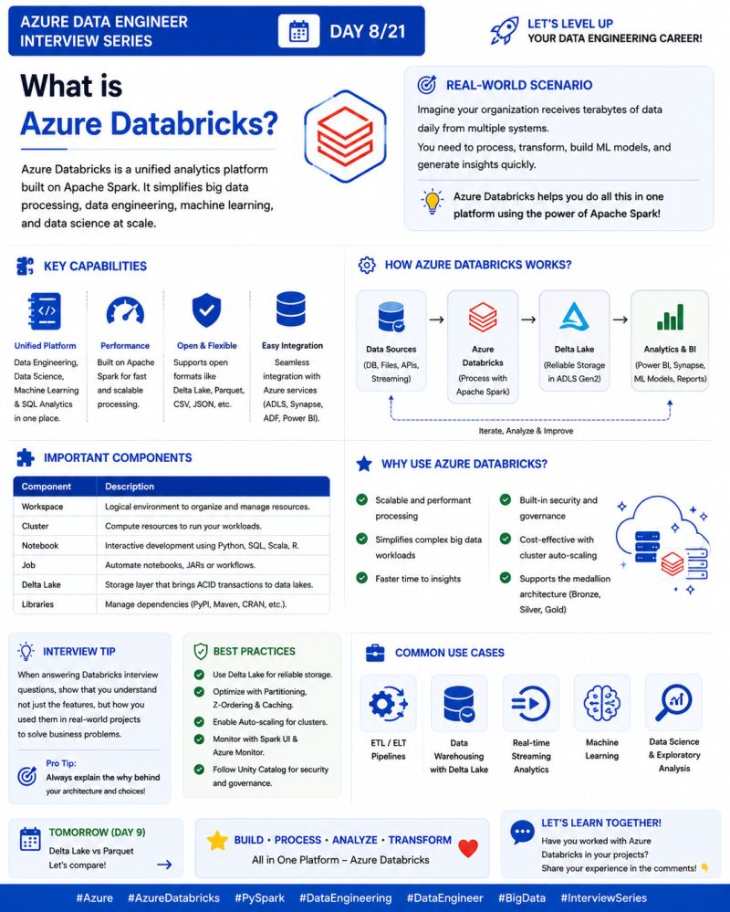

🚀 Azure Data Engineer Interview Series | Day 9/21
One of the most common Azure Databricks interview questions is:
❓ Delta Lake vs Parquet – What's the Difference?
Many people think Delta Lake and Parquet are the same.
They're not.
Parquet is a columnar file format used to store data efficiently.
Delta Lake is a storage layer built on top of Parquet that adds enterprise features like ACID transactions, Time Travel, Schema Enforcement, and MERGE operations.
Think of it this way:
📄 Parquet = A File Format
🛡️ Delta Lake = A Reliable Storage Layer built on Parquet
💼 Real-World Scenario
Imagine you're ingesting millions of sales records every day.
With Parquet, you can store the data efficiently, but handling updates, deletes, or concurrent writes becomes challenging.
With Delta Lake, you can:
✅ Update existing records
✅ Delete incorrect data
✅ Perform UPSERTs using MERGE
✅ Query previous versions using Time Travel
That's why most modern Azure Databricks projects use Delta Lake instead of plain Parquet.
🎯 Key Differences
ParquetDelta LakeColumnar file formatStorage layer built on ParquetFast readsFast reads + ACID transactionsNo Time TravelSupports Time TravelNo MERGE supportSupports MERGE, UPDATE & DELETEBasic schemaSchema Enforcement & Evolution
💡 Interview Tip
If an interviewer asks:
"Why do companies prefer Delta Lake over Parquet?"
A strong answer is:
✔️ ACID Transactions
✔️ Data Reliability
✔️ Time Travel
✔️ Schema Enforcement
✔️ Easy UPSERTs with MERGE
These are the features that make Delta Lake production-ready.
💬 Let's learn together!
Have you worked with Delta Lake in your projects?
Or are you still using Parquet?
👇 Share your experience in the comments!
📅 Tomorrow (Day 10): MERGE INTO Explained with a Real-World Upsert Scenario.
hashtag#Azure hashtag#AzureDatabricks hashtag#DeltaLake hashtag#Parquet hashtag#PySpark hashtag#ApacheSpark hashtag#DataEngineering hashtag#BigData hashtag#InterviewPreparation hashtag#MicrosoftAzure
Activate to view larger image,
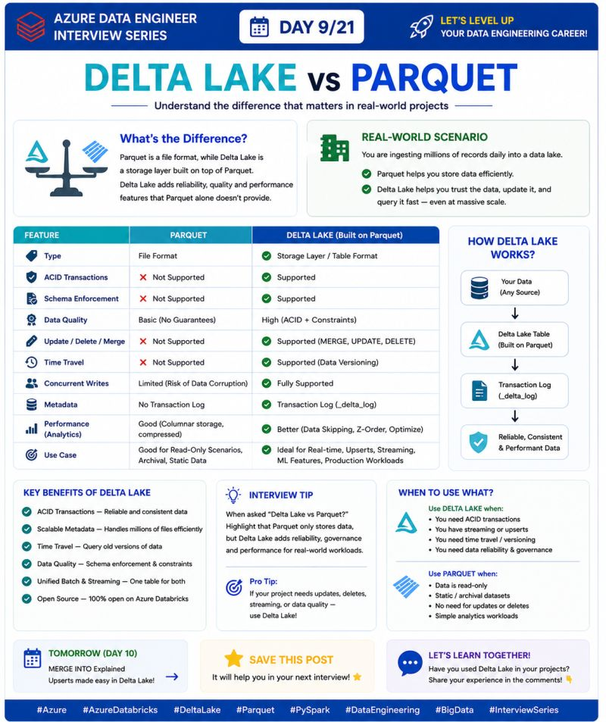

🚀 Azure Data Engineer Interview Series | Day 10/21
One Azure Databricks interview question that is asked in almost every experienced Data Engineer interview:
❓ What is MERGE INTO in Delta Lake?
MERGE INTO is used to UPSERT data into a Delta table.
It allows you to:
✅ Update existing records
✅ Insert new records
✅ Delete records (if required)
—all in a single SQL statement.
Think of it as a combination of INSERT + UPDATE + DELETE.
💼 Real-World Scenario
Imagine your Customer table already contains 1 million records.
Every day, you receive a file with:
New customers
Updated customer details
Corrected records
Instead of deleting and reloading the entire table, you simply use MERGE INTO.
Delta Lake automatically:
✔️ Updates matching records
✔️ Inserts new customers
✔️ Keeps the table consistent and efficient
This is how most enterprise ETL pipelines handle incremental data.
🎯 Basic MERGE Workflow
📥 Source Data
⬇️
🔍 Match records using Primary Key
⬇️
✅ If Match → UPDATE
❌ If No Match → INSERT
(Optional) → DELETE old records if required
💡 Interview Tip
A common follow-up question is:
"Why use MERGE instead of INSERT OVERWRITE?"
A strong answer:
✔️ MERGE updates only the changed records.
✔️ It avoids reloading the entire table.
✔️ Saves compute cost and processing time.
✔️ Ideal for Incremental Loads and Slowly Changing Dimensions (SCD).
This is one of the biggest advantages of Delta Lake over traditional file formats.
💬 Let's learn together!
Have you used MERGE INTO in your project?
Which use case did you implement—Incremental Load, SCD Type 1, or SCD Type 2?
👇 Share your experience in the comments!
📅 Tomorrow (Day 11): Time Travel in Delta Lake – Query Previous Versions of Your Data.
hashtag#Azure hashtag#AzureDatabricks hashtag#DeltaLake hashtag#MERGE hashtag#PySpark hashtag#ApacheSpark hashtag#DataEngineering hashtag#BigData hashtag#InterviewPreparation hashtag#MicrosoftAzure
Activate to view larger image,
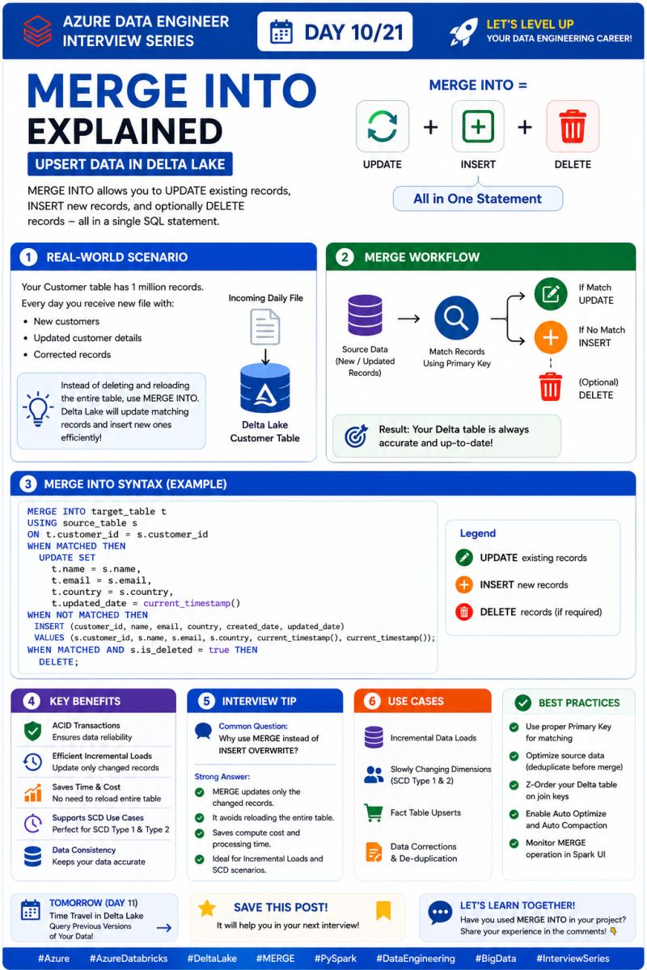

🚀 Azure Data Engineer Interview Series | Day 11/21
One of the most interesting Azure Databricks interview questions:
❓ What is Time Travel in Delta Lake?
Imagine accidentally updating or deleting important production data.
Would you restore the entire backup?
Not with Delta Lake.
Time Travel allows you to query or restore previous versions of your Delta table using a timestamp or version number.
Think of it as undo for your data.
💼 Real-World Scenario
Imagine your Sales table contains 10 million records.
A developer accidentally updates thousands of rows with incorrect values.
Instead of restoring the entire table from backup, you can simply use Time Travel to:
✅ View the table before the change
✅ Compare old and new data
✅ Restore the correct version if required
This saves hours of recovery time and minimizes business impact.
🎯 How Time Travel Works
Every change made to a Delta table is recorded in the Transaction Log (_delta_log).
You can query a previous version using:
✔️ Version Number
or
✔️ Timestamp
This makes debugging and data recovery much easier.
💡 Interview Tip
A common interview question is:
"What are the advantages of Time Travel in Delta Lake?"
A strong answer:
✔️ Recover accidental updates or deletes
✔️ Audit historical data
✔️ Compare different versions of a dataset
✔️ Debug production issues quickly
✔️ Restore previous data without reloading the entire table
These are key reasons why enterprises prefer Delta Lake for production workloads.
⚠️ Important Note
Time Travel is not permanent.
Running VACUUM removes old files based on the configured retention period, so very old versions may no longer be available.
💬 Let's learn together!
Have you ever used Time Travel to recover data or troubleshoot an issue?
👇 Share your experience in the comments!
📅 Tomorrow (Day 12): OPTIMIZE & Z-ORDER – Boost Delta Lake Performance.
hashtag#Azure hashtag#AzureDatabricks hashtag#DeltaLake hashtag#TimeTravel hashtag#PySpark hashtag#ApacheSpark hashtag#DataEngineering hashtag#BigData hashtag#InterviewPreparation hashtag#MicrosoftAzure
Activate to view larger image,
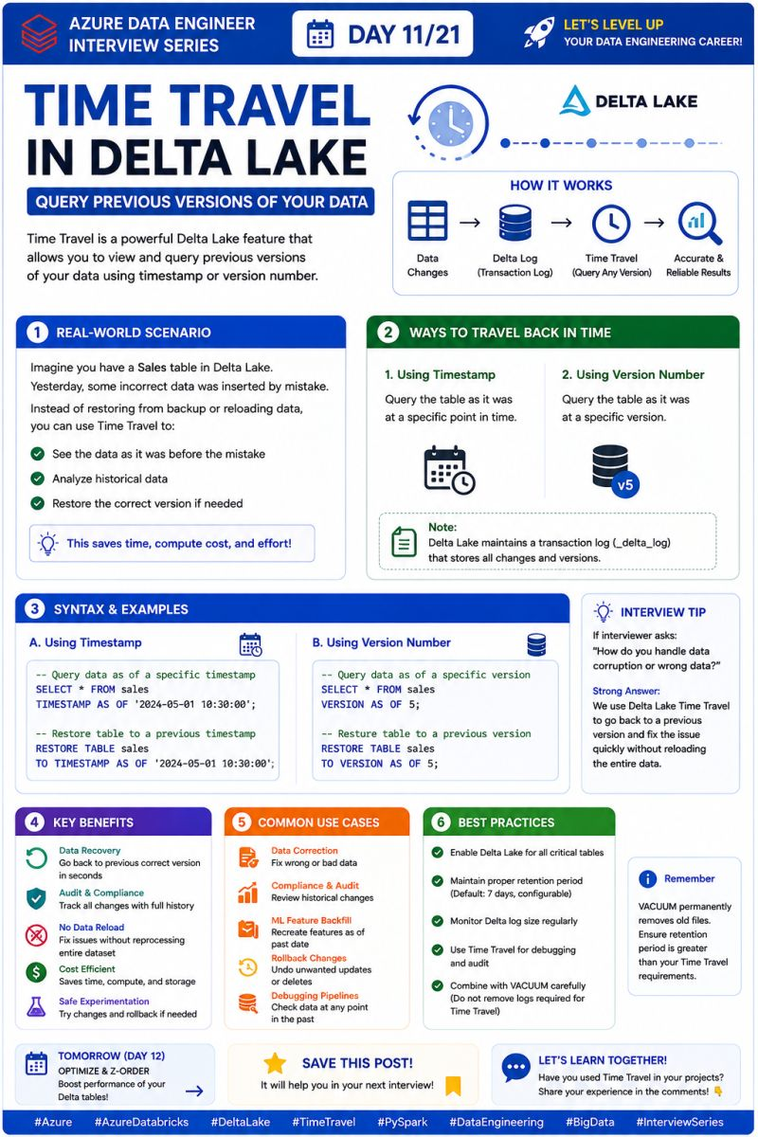

🚀 Azure Data Engineer Interview Series | Day 12/21
One optimization technique that almost every Azure Databricks interviewer expects you to know:
❓ What are OPTIMIZE and Z-ORDER in Delta Lake?
As your Delta tables grow, performance starts to degrade because of too many small files and inefficient data layout.
That's where OPTIMIZE and Z-ORDER come in.
Think of them as performance boosters for your Delta Lake tables.
💼 Real-World Scenario
Imagine your Sales Fact table receives 5 million new records every day.
After a few months:
❌ Thousands of small files are created.
❌ Queries become slower.
❌ More data is scanned, increasing compute cost.
To solve this:
✅ Run OPTIMIZE to compact many small files into fewer, larger files.
✅ Use Z-ORDER on frequently filtered columns (like CustomerID or OrderDate) so related data is stored together.
The result?
⚡ Faster queries
💰 Lower compute cost
🚀 Better overall performance
🎯 What's the Difference?
🔹 OPTIMIZE
✔️ Combines small files into larger files
✔️ Reduces file fragmentation
✔️ Improves read performance
🔹 Z-ORDER
✔️ Reorganizes data based on selected columns
✔️ Improves Data Skipping
✔️ Best for columns used in WHERE, JOIN, and GROUP BY
💡 Interview Tip
A common interview question is:
"When should you use Z-ORDER?"
A strong answer:
👉 Use Z-ORDER on columns that are frequently used in filters or joins.
Example:
CustomerID
OrderDate
ProductID
Avoid using it on columns with very low cardinality (such as Gender or Boolean flags), as it usually provides little performance benefit.
⚡ Best Practice
For large production tables:
1️⃣ Load the data
2️⃣ Run OPTIMIZE
3️⃣ Apply Z-ORDER on frequently queried columns
This combination is widely used to improve query performance in enterprise Databricks environments.
💬 Let's learn together!
Have you ever used OPTIMIZE or Z-ORDER in your Databricks projects?
👇 Which column did you choose for Z-ORDER, and why?
📅 Tomorrow (Day 13): Unity Catalog – Centralized Data Governance in Azure Databricks.
hashtag#Azure hashtag#AzureDatabricks hashtag#DeltaLake hashtag#Optimize hashtag#ZOrder hashtag#PySpark hashtag#ApacheSpark hashtag#DataEngineering hashtag#BigData hashtag#InterviewPreparation
Activate to view larger image,
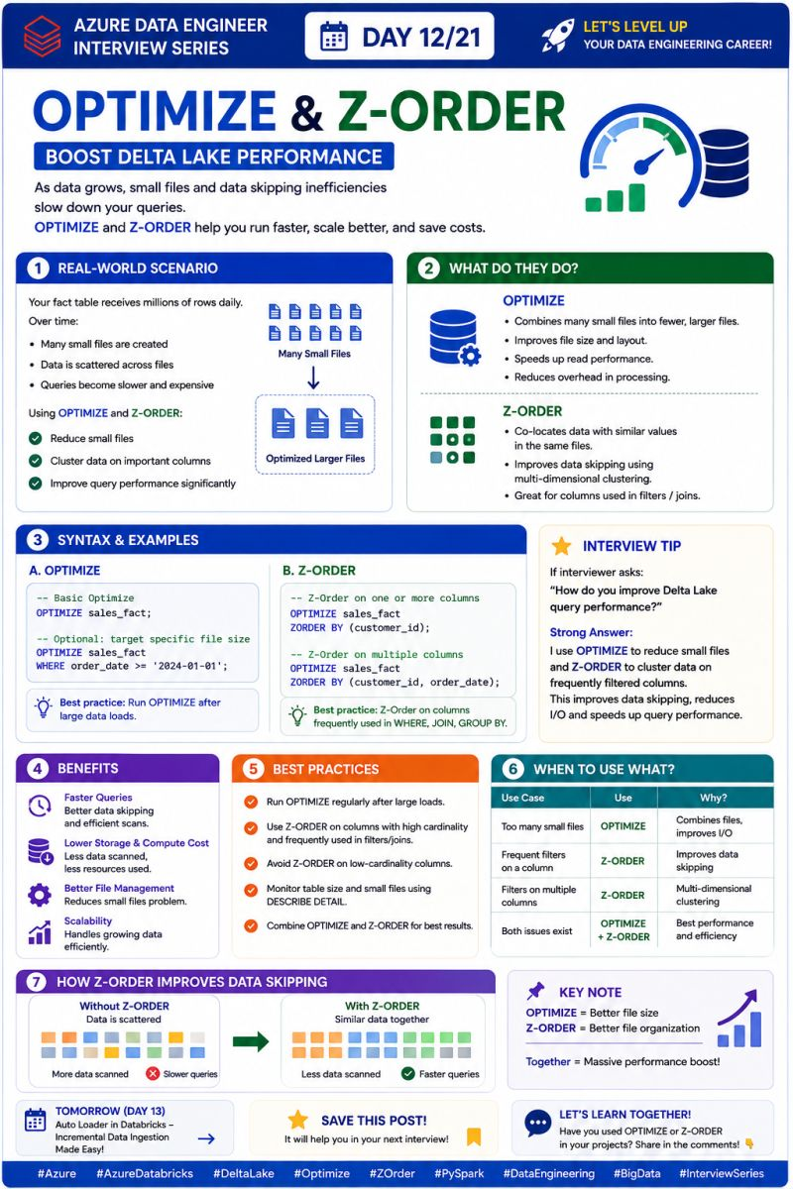

🚀 Azure Data Engineer Interview Series | Day 13/21
One Azure Databricks topic that every experienced Data Engineer should know:
❓ What is Unity Catalog?
As organizations grow, managing data access, permissions, governance, and security across multiple workspaces becomes challenging.
That's where Unity Catalog comes in.
Unity Catalog is Databricks' centralized governance solution that helps you manage data, permissions, metadata, and lineage from a single place.
Think of it as the "single source of governance" for your entire Lakehouse.
💼 Real-World Scenario
Imagine your company has multiple teams:
👨‍💻 Data Engineering
📊 BI Team
🤖 Data Science
💰 Finance
Each team needs access to different datasets.
Without Unity Catalog:
❌ Permissions are managed separately.
❌ Security becomes difficult.
❌ Data duplication increases.
With Unity Catalog:
✅ Centralized access control
✅ Fine-grained permissions
✅ Data lineage
✅ Secure data sharing across workspaces
Everything is managed from one place.
🎯 Key Components
🔹 Metastore → Stores metadata for your organization.
🔹 Catalog → Top-level container for organizing data.
🔹 Schema (Database) → Groups related tables.
🔹 Tables / Views / Volumes → Actual data objects.
🔹 Grants → Control who can read, write, or modify data.
💡 Interview Tip
A common interview question is:
"Why should companies use Unity Catalog?"
A strong answer:
✔️ Centralized Data Governance
✔️ Fine-Grained Access Control
✔️ Data Lineage & Auditing
✔️ Secure Data Sharing
✔️ Better Compliance & Security
This shows you understand not just data engineering, but also enterprise data governance, which is increasingly important in modern organizations.
⚡ Best Practice
Always follow the Principle of Least Privilege.
Give users only the minimum permissions they need to perform their tasks.
This improves both security and compliance.
💬 Let's learn together!
Have you worked with Unity Catalog in Azure Databricks?
👇 What feature do you find most useful—Data Lineage, Access Control, or Centralized Governance?
📅 Tomorrow (Day 14): Bronze, Silver & Gold Architecture – The Medallion Architecture Explained.
hashtag#Azure hashtag#AzureDatabricks hashtag#UnityCatalog hashtag#DataGovernance hashtag#DeltaLake hashtag#PySpark hashtag#DataEngineering hashtag#BigData hashtag#InterviewPreparation hashtag#MicrosoftAzure
Activate to view larger image,
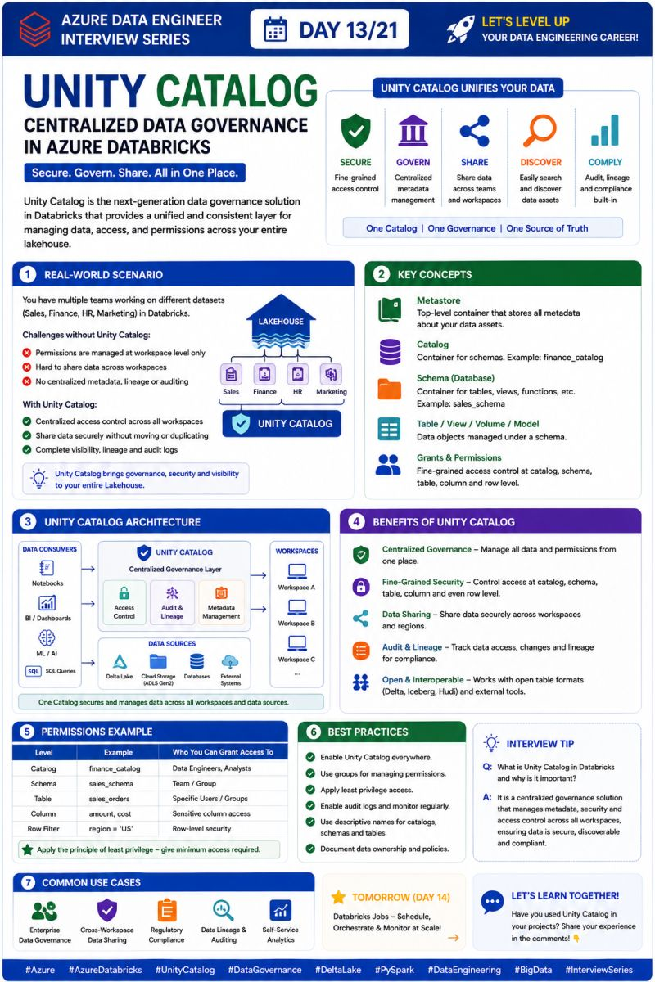

🚀 Azure Data Engineer Interview Series | Day 14/21
One architecture that almost every Azure Data Engineer uses in production:
❓ What is the Bronze, Silver & Gold (Medallion) Architecture?
The Medallion Architecture is a data design pattern that organizes data into three layers:
🥉 Bronze → Raw Data
🥈 Silver → Cleaned & Validated Data
🥇 Gold → Business-Ready Data
This approach makes data pipelines more scalable, maintainable, and reliable.
💼 Real-World Scenario
Imagine your company receives data from:
📊 ERP Systems
🛒 E-commerce Applications
🌐 APIs
📱 IoT Devices
Instead of transforming everything in one step, the data flows through three layers.
🥉 Bronze Layer
✅ Stores raw data exactly as received.
✅ No transformations.
✅ Used for auditing and replaying data if required.
🥈 Silver Layer
✅ Cleans and validates data.
✅ Removes duplicates.
✅ Handles null values.
✅ Applies business rules and joins.
This is where data becomes trustworthy.
🥇 Gold Layer
✅ Business-ready data.
✅ Aggregated KPIs and metrics.
✅ Optimized for reporting.
✅ Used by Power BI, dashboards, and business users.
🎯 Why is Medallion Architecture Important?
✔️ Better Data Quality
✔️ Easier Debugging
✔️ Reusable Data Pipelines
✔️ Faster Analytics
✔️ Improved Scalability
Each layer has a clear responsibility, making pipelines easier to maintain as data volumes grow.
💡 Interview Tip
A common interview question is:
"Why do organizations use Medallion Architecture?"
A strong answer:
👉 It separates Raw, Cleaned, and Curated data into different layers, improving data quality, scalability, governance, and maintainability while allowing multiple teams to work independently.
⚡ Best Practice
Don't skip the Bronze layer.
Always preserve the original source data so you can replay pipelines, troubleshoot issues, or recover from transformation errors.
💬 Let's learn together!
Which layer do you spend the most time working with in your projects?
🥉 Bronze
🥈 Silver
🥇 Gold
👇 Share your answer in the comments!
📅 Tomorrow (Day 15): Spark Architecture – Driver, Executors & Cluster Manager Explained.
hashtag#Azure hashtag#AzureDatabricks hashtag#MedallionArchitecture hashtag#BronzeSilverGold hashtag#DeltaLake hashtag#PySpark hashtag#DataEngineering hashtag#BigData hashtag#InterviewPreparation hashtag#MicrosoftAzure
Activate to view larger image,
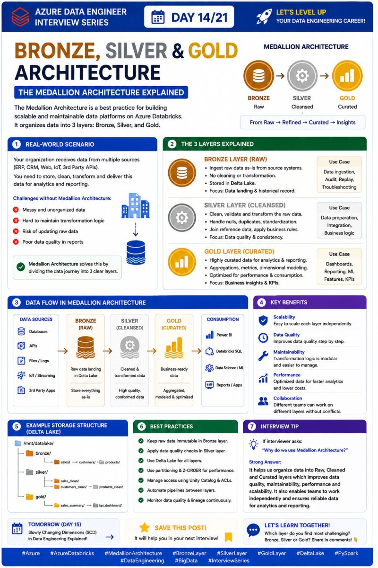

🚀 Azure Data Engineer Interview Series | Day 15/21
One question that almost every Azure Databricks interview includes:
❓ Can you explain Spark Architecture?
Understanding Spark Architecture is essential because it explains how PySpark processes massive amounts of data in parallel.
At a high level, Spark consists of three main components:
🧠 Driver
⚙️ Cluster Manager
💻 Executors
Together, they distribute and execute your application across multiple machines.
💼 Real-World Scenario
Imagine you're processing 2 TB of sales data in Azure Databricks.
Instead of one machine processing all the data, Spark distributes the workload across multiple executors.
Here's what happens:
✅ You submit a PySpark job.
✅ The Driver creates an execution plan (DAG).
✅ The Cluster Manager allocates resources.
✅ Executors process different partitions of data in parallel.
✅ Results are returned to the Driver.
This distributed execution is why Spark is so fast.
🎯 Key Components
🧠 Driver
✔️ Starts your Spark application
✔️ Creates the SparkSession
✔️ Builds the DAG (execution plan)
✔️ Coordinates Executors
⚙️ Cluster Manager
✔️ Allocates CPU & Memory
✔️ Launches Executors
✔️ Manages cluster resources
Examples:
• Standalone
• YARN
• Kubernetes
💻 Executors
✔️ Execute tasks
✔️ Process partitions in parallel
✔️ Cache data in memory
✔️ Return results to the Driver
💡 Interview Tip
A common interview question is:
"What is the difference between Driver and Executor?"
A strong answer:
🧠 Driver → Plans and coordinates the job.
💻 Executors → Perform the actual computation on the data.
A simple way to remember it:
Driver thinks. Executors work.
⚡ Best Practice
Avoid running everything on the Driver.
Instead, use distributed transformations so the workload is executed on the Executors, where Spark delivers its real performance benefits.
💬 Let's learn together!
Have you ever faced issues related to Driver Memory or Executor Memory while running Spark jobs?
👇 Share your experience in the comments!
📅 Tomorrow (Day 16): RDD vs DataFrame – Which one should you use and why?
hashtag#Azure hashtag#AzureDatabricks hashtag#ApacheSpark hashtag#SparkArchitecture hashtag#PySpark hashtag#DataEngineering hashtag#BigData hashtag#InterviewPreparation hashtag#MicrosoftAzure
Activate to view larger image,
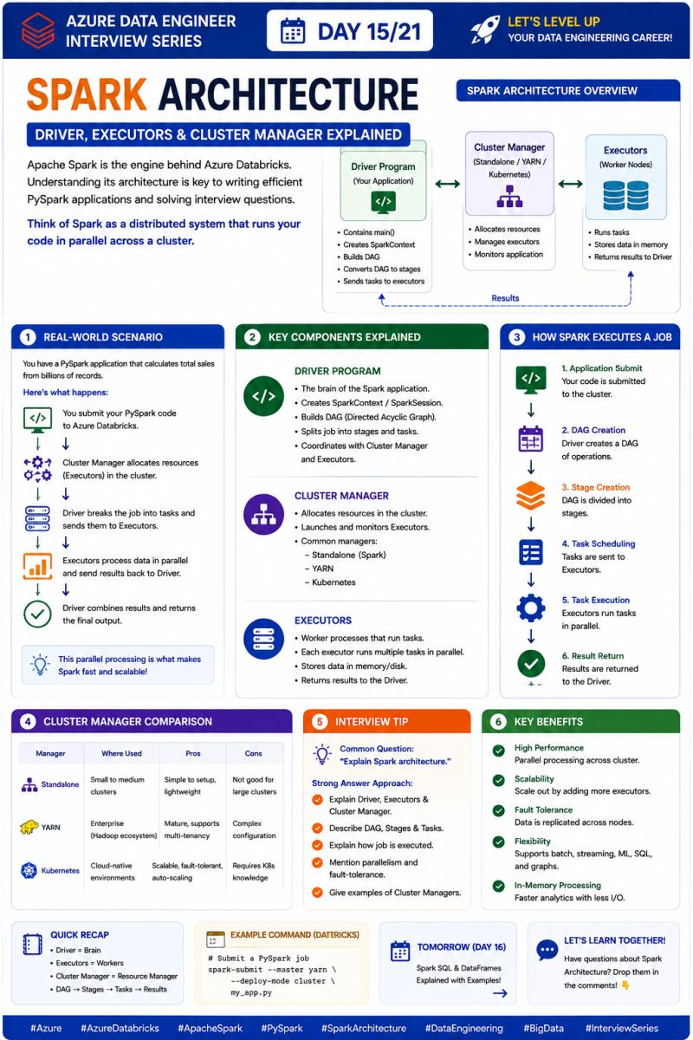

🚀 Azure Data Engineer Interview Series | Day 16/21
One of the most common PySpark interview questions is:
❓RDD vs DataFrame – Which one should you use?
Apache Spark provides two ways to process data:
🔸 RDD (Resilient Distributed Dataset) – A low-level distributed data structure that gives you full control over data processing.
🔹 DataFrame – A high-level abstraction built on top of RDDs that is optimized for performance and easier to use.
In most real-world projects, DataFrames are the preferred choice.
💼 Real-World Scenario
Imagine you're building a sales analytics pipeline.
Your pipeline needs to:
✅ Read data from ADLS
✅ Clean and transform the data
✅ Join multiple tables
✅ Aggregate sales metrics
✅ Load the results into Power BI
For this type of workload, DataFrames are the better option because Spark automatically optimizes the execution plan using the Catalyst Optimizer and Tungsten Engine.
🎯 RDD vs DataFrame
🔸 Use RDD when:
✔️ You need low-level control.
✔️ You're working with unstructured data.
✔️ You're implementing custom transformations.
✔️ You're learning Spark internals.
🔹 Use DataFrame when:
✔️ Working with structured or semi-structured data.
✔️ Building ETL pipelines.
✔️ Performing joins, filters, and aggregations.
✔️ You want better performance with less code.
✔️ You're working in production.
💡 Interview Tip
A common interview question is:
"Why are DataFrames faster than RDDs?"
A strong answer:
👉 DataFrames use the Catalyst Optimizer to optimize query execution and the Tungsten Engine to improve memory management and CPU efficiency.
As a result:
⚡ Better performance
⚡ Lower memory usage
⚡ Easier code maintenance
⚡ Best Practice
Use DataFrames for almost all production workloads.
Use RDDs only when you need fine-grained control or are working with APIs that require RDDs.
💬 Let's learn together!
Which do you use more in your projects—RDD or DataFrame?
👇 Share your experience in the comments!
📅 Tomorrow (Day 17): Transformations vs Actions in Spark – Understanding Lazy Evaluation.
hashtag#Azure hashtag#AzureDatabricks hashtag#ApacheSpark hashtag#PySpark hashtag#RDD hashtag#DataFrame hashtag#DataEngineering hashtag#BigData hashtag#InterviewPreparation hashtag#MicrosoftAzure
Activate to view larger image,
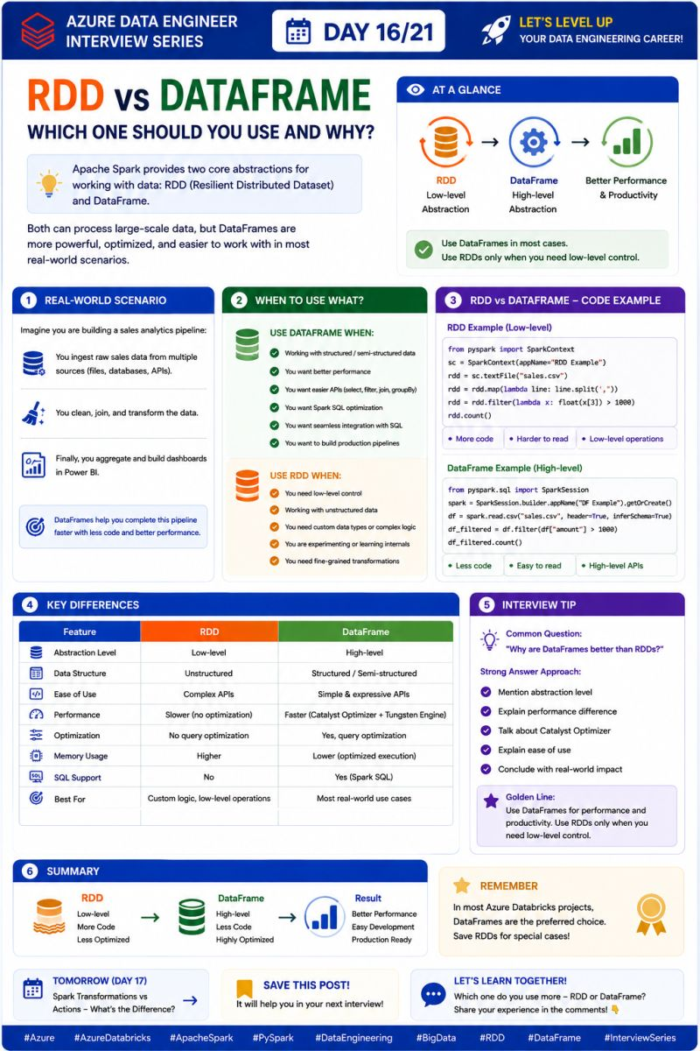

🚀 Azure Data Engineer Interview Series | Day 17/21
One of the most important PySpark interview topics:
❓ Transformations vs Actions in Spark
If you understand this concept, you understand one of the most important ideas behind Spark's Lazy Evaluation.
🔹 Transformations = Build the Plan
Transformations create a new DataFrame/RDD but don't execute immediately.
Examples:
filter() • select() • join() • groupBy() • withColumn()
🔸 Actions = Trigger Execution
Actions actually start the Spark job and return a result or write data.
Examples:
show() • count() • collect() • first() • write()
💼 Real-World Example
Imagine a sales pipeline:
Read → Filter → Join → Aggregate → Write
The first four steps are transformations.
Spark doesn't immediately process the data.
When you call:
df.write.format("delta").save("/sales")
the action triggers execution of the entire logical plan.
That's Lazy Evaluation.
🎯 Why does Spark do this?
Because Spark can optimize the complete execution plan before processing the data.
This can result in:
⚡ Better performance
💰 Efficient resource usage
📉 Less unnecessary computation
🚀 Scalable distributed processing
💡 Interview Tip
If the interviewer asks:
"What's the difference between Transformation and Action?"
Remember this one line:
Transformations build the plan. Actions trigger the execution.
That's the simplest way to explain it confidently.
💬 Let's learn together!
Can you name 3 Transformations and 3 Actions in PySpark?
👇 Drop your answers in the comments!
📅 Tomorrow (Day 18): Broadcast Join – How does Spark optimize joins with small datasets?
hashtag#Azure hashtag#AzureDatabricks hashtag#ApacheSpark hashtag#PySpark hashtag#Spark hashtag#DataEngineering hashtag#BigData hashtag#InterviewPreparation hashtag#MicrosoftAzure
Activate to view larger image,
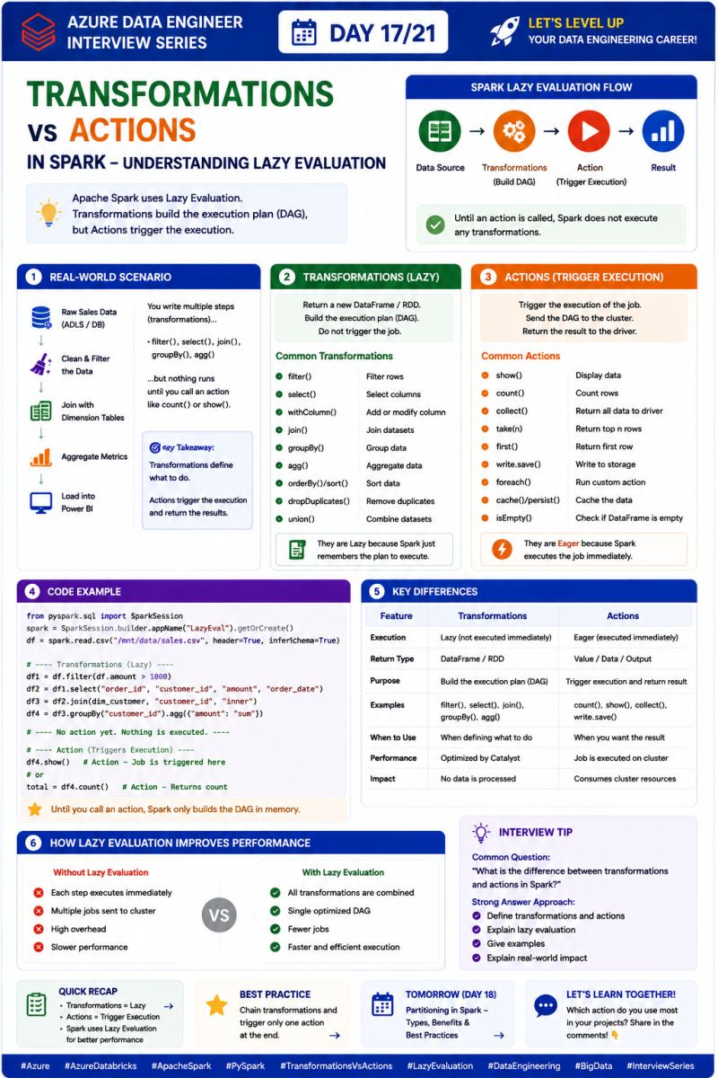

🚀 Azure Data Engineer Interview Series | Day 18/21
One PySpark optimization technique that can make a huge difference in join performance:
❓ What is Broadcast Join in Spark?
A Broadcast Join is used when one of the tables being joined is small enough to fit in the memory of each executor.
Instead of shuffling both datasets across the network, Spark broadcasts the small table to all executors.
Think of it as:
Small table → sent to every executor → Large table processed locally
Less shuffle = faster joins ⚡
💼 Real-World Scenario
Imagine you have:
📊 SalesFact → 100 million rows
📦 ProductDim → 5,000 rows
You need to join them to get product information.
❌ Normal Shuffle Join
Spark may need to redistribute data across executors.
➡️ More network I/O
➡️ More shuffle
➡️ Slower execution
✅ Broadcast Join
Spark sends the small ProductDim table to every executor.
Each executor can then join its portion of SalesFact locally.
➡️ Less shuffle
➡️ Less network traffic
➡️ Faster execution
🧑‍💻 PySpark Example
from pyspark.sql.functions import broadcast result = sales.join( broadcast(product), "product_id" )
You can also allow Spark to automatically choose a broadcast join when the table is below the configured broadcast threshold.
🎯 When Should You Use Broadcast Join?
✅ One table is relatively small
✅ The small table can comfortably fit in executor memory
✅ You're joining a large fact table with a small dimension table
❌ Don't broadcast large tables—it can cause executor memory pressure or OOM errors.
💡 Interview Tip
If the interviewer asks:
"How does Broadcast Join improve Spark performance?"
Remember:
It avoids shuffling the small table by broadcasting it to all executors, allowing the join to happen locally and reducing network overhead.
That's the key point interviewers are looking for.
💬 Let's learn together!
Have you used Broadcast Join in your PySpark projects?
👇 What kind of table did you broadcast?
📅 Tomorrow (Day 19): Delta Lake ACID Properties – Why is Delta Lake reliable for production data?
hashtag#Azure hashtag#AzureDatabricks hashtag#ApacheSpark hashtag#PySpark hashtag#BroadcastJoin hashtag#SparkOptimization hashtag#DataEngineering hashtag#BigData hashtag#InterviewPreparation hashtag#MicrosoftAzure
Activate to view larger image,
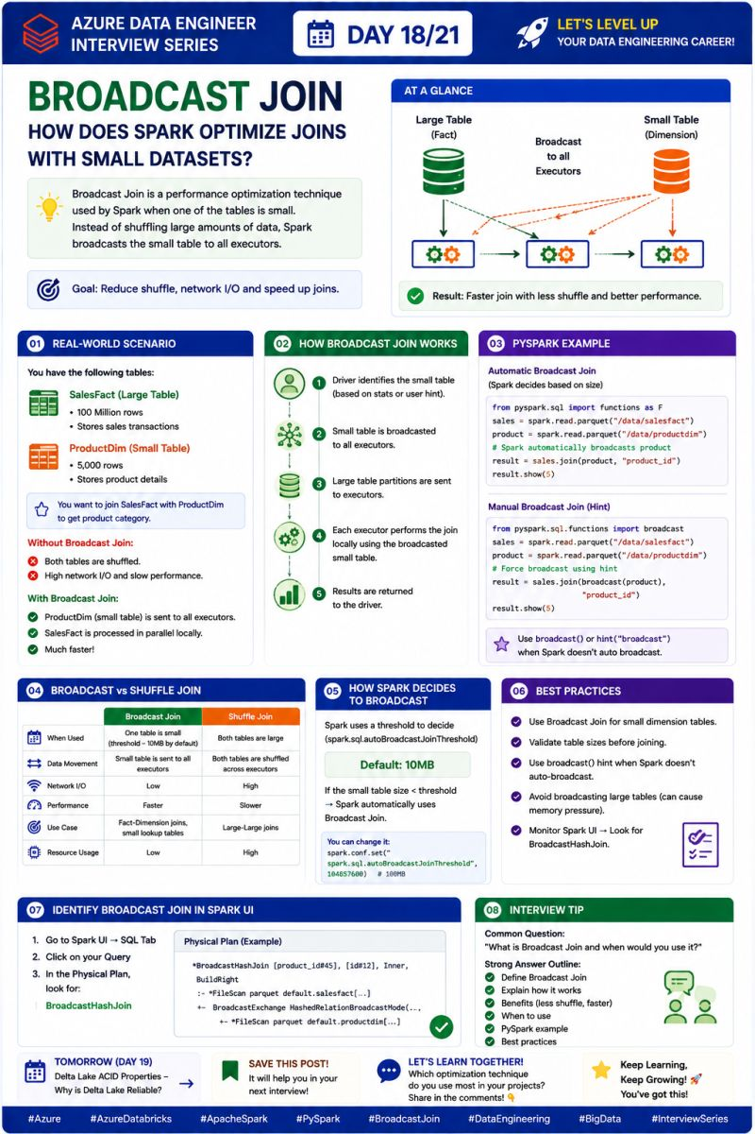

Azure Data Engineer Interview Series | Day 19/21
One SQL concept that every Data Engineer should be comfortable with:
❓ What are SQL Window Functions?
Window Functions perform calculations across a set of related rows without collapsing the rows into a single result.
That's the key difference from GROUP BY.
For example, you can calculate:
✅ Running totals
✅ Rankings
✅ Previous/next values
✅ Moving averages
✅ Comparisons with other rows
💼 Real-World Scenario
Imagine you have a Sales table:
CustomerID | OrderDate | Amount
You want to calculate each customer's:
➡️ Total sales
➡️ Running sales total
➡️ Rank of each order
With Window Functions, you can do this while keeping every individual order row.
Example:
SELECT CustomerID, OrderDate, Amount, SUM(Amount) OVER ( PARTITION BY CustomerID ORDER BY OrderDate ) AS RunningTotal FROM Sales;
Here:
PARTITION BY → Defines the group.
ORDER BY → Defines the sequence within that group.
OVER() → Tells SQL to perform the calculation as a window operation.
🎯 Common Window Functions
🔹 ROW_NUMBER() → Assigns a unique sequential number
🔹 RANK() → Assigns ranking with gaps after ties
🔹 DENSE_RANK() → Assigns ranking without gaps
🔹 SUM() → Running/partitioned totals
🔹 LAG() → Access previous row
🔹 LEAD() → Access next row
💡 Interview Tip
A common question is:
"What's the difference between GROUP BY and Window Functions?"
Remember:
GROUP BY reduces rows. Window Functions keep the rows and add calculated information to them.
That's one of the most important SQL concepts for Data Engineer interviews.
💬 Let's learn together!
Which Window Function do you use most?
ROW_NUMBER() | RANK() | LAG() | SUM() OVER()
👇 Drop your answer in the comments!
📅 Tomorrow (Day 20): ROW_NUMBER vs RANK vs DENSE_RANK – The difference every Data Engineer should know.
hashtag#Azure hashtag#AzureDataEngineer hashtag#SQL hashtag#SQLServer hashtag#WindowFunctions hashtag#DataEngineering hashtag#AzureDatabricks hashtag#PySpark hashtag#InterviewPreparation hashtag#MicrosoftAzure
Activate to view larger image,
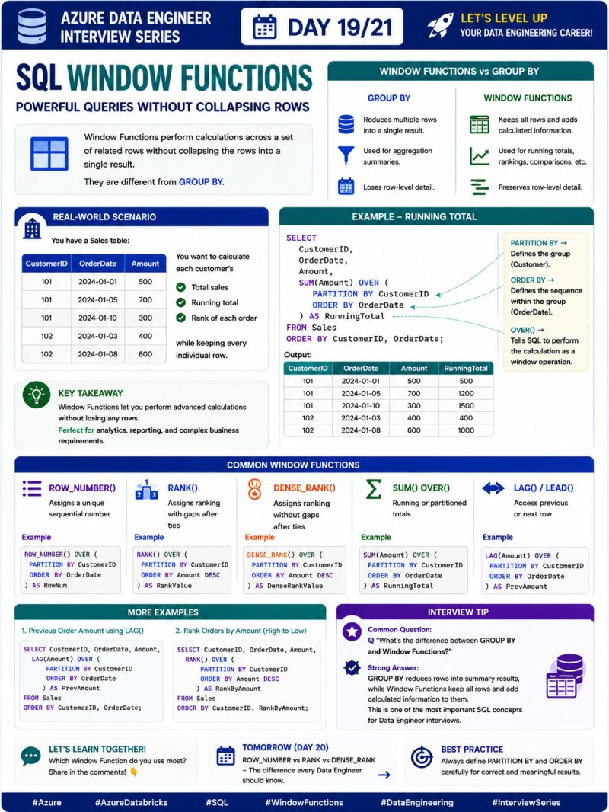

🚀 Azure Data Engineer Interview Series | Day 20/21
One SQL question that looks simple but is frequently asked in Data Engineer interviews:
❓ ROW_NUMBER() vs RANK() vs DENSE_RANK()
All three are Window Functions used to assign numbers/ranks to rows.
The real difference?
👉 How they handle ties.
🔹 1. ROW_NUMBER()
Assigns a unique sequential number to every row.
If two employees have the same salary, they still get different numbers.
Example:
1, 2, 3, 4, 5
✅ Use when you need a unique row number.
🔹 2. RANK()
Rows with the same value receive the same rank.
But the next rank is skipped.
Example:
1, 2, 2, 4, 5
✅ Use when ranking gaps are meaningful.
🔹 3. DENSE_RANK()
Rows with the same value receive the same rank.
But the next rank is NOT skipped.
Example:
1, 2, 2, 3, 4
✅ Use when you want ranking without gaps.
💼 Real-World Example
Suppose employees have these sales:
EmployeeSalesAlice9000Bob7000Charlie7000David5000
With:
ROW_NUMBER() → 1, 2, 3, 4 RANK() → 1, 2, 2, 4 DENSE_RANK() → 1, 2, 2, 3
That's the difference you need to remember.
💡 Interview Shortcut
Just remember:
ROW_NUMBER = Unique numbers
RANK = Ties + Gaps
DENSE_RANK = Ties + No Gaps
If an interviewer gives you a ranking problem, first ask:
"How should ties be handled?"
That usually tells you which function to use.
💬 Let's learn together!
If two employees have the same salary, which function would you use for ranking?
ROW_NUMBER() | RANK() | DENSE_RANK()
👇 Drop your answer in the comments!
📅 Tomorrow (Day 21): Top 20 Azure Data Engineer Interview Questions — our final day! 🎯
hashtag#Azure hashtag#AzureDataEngineer hashtag#SQL hashtag#SQLServer hashtag#WindowFunctions hashtag#ROWNUMBER hashtag#RANK hashtag#DENSERANK hashtag#DataEngineering hashtag#InterviewPreparation hashtag#MicrosoftAzure
Activate to view larger image,
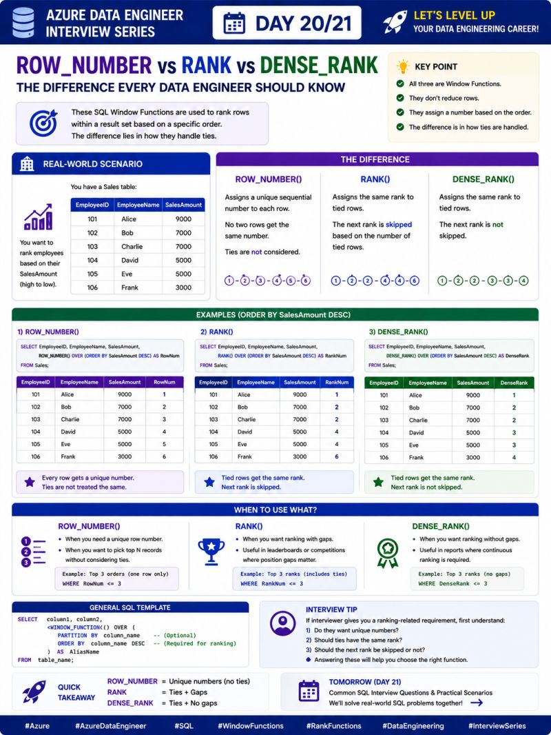

🚀 Azure Data Engineer Interview Series | Day 21/21
21 days. 21 interview-focused topics. And today, we finish the series! 🎯
If you're preparing for an Azure Data Engineer interview, save this post. These are the questions I would revise before an interview.
🔥 Top 20 Azure Data Engineer Interview Questions
☁️ Azure & ADF
1. What is Azure Data Factory and how does it work?
2. Azure IR vs Self-Hosted IR — what's the difference?
3. How do you implement an incremental load using a Watermark?
4. How do you build a metadata-driven pipeline?
5. How do you handle pipeline failures and errors in ADF?
🧱 Databricks & Delta Lake
6. What is Azure Databricks and why use it?
7. Delta Lake vs Parquet — what's the difference?
8. What is MERGE INTO and where would you use it?
9. What is Time Travel in Delta Lake?
10. How do OPTIMIZE and Z-ORDER improve performance?
11. What is Unity Catalog?
12. Explain Bronze, Silver and Gold architecture.
⚡ Spark & PySpark
13. Explain Spark Architecture — Driver, Executors and Cluster Manager.
14. RDD vs DataFrame — when would you use each?
15. Transformations vs Actions — what is Lazy Evaluation?
16. What is a Broadcast Join and when should you use it?
17. How would you optimize a slow Spark job?
🗄️ SQL
18. What are SQL Window Functions?
19. ROW_NUMBER() vs RANK() vs DENSE_RANK()?
20. How would you solve a real-world SQL problem using CTEs, joins and Window Functions?
🎯 21-Day Series Completed!
Day 1 → Azure Data Factory
Day 2 → Integration Runtime
Day 3 → Incremental Load
Day 4 → Lookup + ForEach
Day 5 → Metadata-Driven Pipeline
Day 6 → Error Handling
Day 7 → ADF Cheat Sheet
Day 8 → Azure Databricks
Day 9 → Delta Lake vs Parquet
Day 10 → MERGE INTO
Day 11 → Time Travel
Day 12 → OPTIMIZE + Z-ORDER
Day 13 → Unity Catalog
Day 14 → Bronze/Silver/Gold
Day 15 → Spark Architecture
Day 16 → RDD vs DataFrame
Day 17 → Transformations vs Actions
Day 18 → Broadcast Join
Day 19 → SQL Window Functions
Day 20 → ROW_NUMBER vs RANK vs DENSE_RANK
Day 21 → Top 20 Interview Questions 🎯
💬 Your turn!
If you could ask an Azure Data Engineer one interview question, what would you ask?
👇 Drop it in the comments.
And if you've followed this 21-day series, thank you! ❤️
Keep learning. Keep building. Keep sharing.
hashtag#Azure hashtag#AzureDataEngineer hashtag#DataEngineering hashtag#SQL hashtag#PySpark hashtag#AzureDataFactory hashtag#AzureDatabricks hashtag#DeltaLake hashtag#ApacheSpark hashtag#InterviewPreparation hashtag#MicrosoftAzure hashtag#DataEngineer hashtag#CareerGrowth
Activate to view larger image,
